

**NED UNIVERSITY OF ENGINEERING**

**&**

**TECHNOLOGY**

**DEPARTMENT OF COMPUTER SCIENCE & IT**

**CT-261 Data Base Management Systems**

*Instructor: Sir Umer Farooq*

**PROJECT REPORT**

**UNIVERSITY MANAGEMENT SYSTEM**

**Members:**

|  |  |
| --- | --- |
| MUSAB UMAIR | CT-22095 |
| FAIZAN TAHIR | CT-22074 |
| SHAHZAIN ADIL | CT-22076 |
| NOFIL AHMED KHAN | CT-22301 |

**ORGANIZATION INTRODUCTION:**

At our institution, we prioritize excellence in education by providing a seamless and comprehensive learning experience. Our advanced system ensures personalized attention for every student, from admission to graduation. Our dedicated teachers are equipped with tools to manage classes, prepare tests, and track student progress meticulously. Our administrators oversee all operations, including library management and fee processing, ensuring a smooth and efficient academic environment. Join us in nurturing the leaders of tomorrow in an enriching and supportive educational setting. Welcome to a world of possibilities. Welcome to our institution.

**PROBLEM OF ORGANIZATION (Fact Finding)**

In our pursuit of educational excellence, we have identified a significant challenge in effective communication and data management across departments and stakeholders. This issue has led to:

1. **Fragmented Information Systems:** Disconnected modules result in inefficiencies and data discrepancies.
2. **Delayed Communication:** Students and staff experience delays in receiving important updates, causing confusion.
3. **Administrative Overload:** Manual data management overwhelms administrative staff, increasing errors.
4. **Limited Teacher-Student Interaction:** Feedback and communication between teachers and students need improvement.

**Proposed Solutions:**

1. **Integrated Information System:** A unified dashboard for real-time updates and data consolidation.
2. **Automated Notification System:** Timely SMS, email, and app notifications for important updates.
3. **Administrative Support Tools:** Advanced tools and training to reduce manual workload and errors.
4. **Enhanced Communication Platforms:** Improved platforms for better teacher-student interaction.

Addressing these challenges will streamline operations, improve communication, and enhance the educational experience for students and staff alike.

**OVERVIEW OF THE SYSTEM:**

Our institution's advanced management system streamlines academic and administrative processes, ensuring a seamless experience for all stakeholders.

**Key Features:**

**Student Management:** Tracks student journeys from admission to graduation, including personal information, attendance, test scores, and fee payments.

**Teacher Management:** Provides tools for managing classes, grading tests, and recording attendance, facilitating efficient communication with students.

**Administrative Operations:** Supports daily tasks like posting notices, managing library resources, and processing financial transactions.

**Library Management:** Manages book inventories, borrowing records, and returns, offering easy access to academic resources.

**Fee Management:** Handles financial transactions with transparency and efficiency.

**Performance Tracking:** Monitors student performance, aiding in informed decision-making and personalized support.

**Communication and Notifications:** Ensures timely updates via SMS, email, and mobile app alerts.

**LIMITATIONS:**

* **Fragmented Information Systems:** Disconnected modules can lead to inefficiencies and data discrepancies.
* **Delayed Communication:** Important updates may not reach stakeholders promptly, causing confusion.
* **Administrative Overload:** High manual data management demands increase the risk of errors.
* **Limited Teacher-Student Interaction:** Feedback and communication channels between teachers and students need enhancement.
* **Scalability Issues:** The system may face challenges adapting to rapid increases in the number of users or data volume.
* **Integration Challenges:** Difficulty in integrating with external systems or newer technologies.

**LOGICAL ENTITY RELATIONSHIP DIAGRAM:**

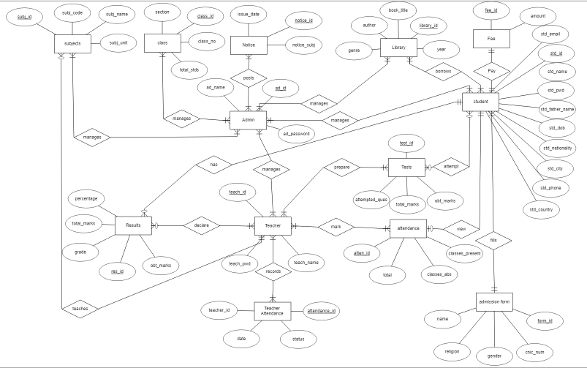

**FOREIGN KEYS:**

* **subjects**

subj_id (Foreign key to sub_id in subject)

* **class**

class_id (Foreign key to class_id in subject)

* **Notice**

class_id (Foreign key to class_id in class)

notice_id (Primary key)

* **Library**

library_id (Foreign key to lib_id in admin)

* **Fee**

fee_id (Foreign key to fee_id in student)

* **student**

std_id (Primary key)

class_id (Foreign key to class_id in class)

* **Admin**

ad_id (Primary key)

* **Tests**

test_id (Foreign key to test_id in teacher)

* **Teacher**

teach_id (Foreign key to teach_id in class)

teacher_id (Foreign key to teacher_id in teacher attendance)

* **Teacher Attendance**

attendance_id (Foreign key to attendance_id in teacher)

* **Results**

res_id (Primary key)

teach_id (Foreign key to teach_id in teacher)

std_id (Foreign key to std_id in student)

* **admission form**

form_id (Primary key)

std_id (Foreign key to std_id in student)

**Application of Entity and Referential Integrity:**

**Subjects and Class:**

* + Each subject and class must have a unique identifier (subj_id and class_id respectively), ensuring entity integrity.
  + subj_id in subjects and class_id in class must exist in their respective referenced tables, maintaining referential integrity.

**Notices:**

* + Each notice must have a unique notice_id.
  + class_id in Notice must exist in class, ensuring the class referred to in the notice exists.

**Library and Admin:**

* + library_id must be unique.
  + library_id in Library must correspond to an existing lib_id in Admin.

**Fees:**

* + fee_id must be unique.
  + fee_id in Fee must exist in student, ensuring the fee record is associated with an existing student.

**Students:**

* + std_id must be unique.
  + class_id in student must exist in class, linking students to existing classes.

**Tests:**

* + test_id must be unique.
  + test_id in Tests must exist in teacher, ensuring tests are associated with existing teachers.

**Teachers:**

* + teach_id and teacher_id must be unique.
  + teach_id in Teacher must exist in class, linking teachers to existing classes.

**Teacher Attendance:**

* + attendance_id must be unique.
  + attendance_id in Teacher Attendance must exist in teacher, ensuring attendance records are linked to existing teachers.

**Results:**

* + res_id must be unique.
  + teach_id in Results must exist in teacher, and std_id must exist in student, ensuring results are associated with existing teachers and students.

**Admission Forms:**

* + form_id must be unique.
  + std_id in admission form must exist in student, ensuring forms are associated with existing students.

By adhering to these entity and referential integrity rules, we maintain data consistency and reliability across our educational management system, ensuring accurate and trustworthy records.

**General Constraints for the Educational Management System Schema:**

* **Primary Key Constraints:**
  + Ensure each table has a unique primary key to maintain entity integrity.
  + Example: std_id in student, teach_id in teacher, class_id in class.
* **Foreign Key Constraints:**
  + Enforce referential integrity by ensuring foreign keys reference valid primary keys in other tables.
  + Example: class_id in student referencing class_id in class.
* **Unique Constraints:**
  + Ensure certain fields that must be unique across records.
  + Example: std_email in student, ad_name in Admin.
* **Not Null Constraints:**
  + Ensure critical fields are not left empty.
  + Example: std_name, std_email, teach_name, ad_name.
* **Check Constraints:**
  + Validate the values of specific fields based on predefined conditions.
  + Example: std_dob should be a valid date and ensure students are within an acceptable age range.
  + Example: percentage in Results should be between 0 and 100.
* **Default Constraints:**
  + Provide default values for certain fields to ensure consistency and reduce null entries.
  + Example: status in Teacher Attendance can have a default value of 'present'.
* **Domain Constraints:**
  + Limit the values of a field to a specific set of values.
  + Example: gender in admission form can be constrained to ('Male', 'Female', 'Other').
  + Example: grade in Results can be constrained to ('A', 'B', 'C', 'D', 'F').
* **Referential Actions:**
  + Define actions to take on foreign key updates or deletions.
  + Example: ON DELETE CASCADE for class_id in student to automatically delete students when a class is deleted.
  + Example: ON UPDATE CASCADE for teach_id in Results to update the foreign key in results when the teacher's ID changes.
* **Length Constraints:**
  + Restrict the length of certain fields to ensure data consistency.
  + Example: std_name should not exceed 50 characters, std_phone should be exactly 10 digits.
* **Value Constraints:**
  + Enforce specific value constraints on numeric fields.
  + Example: amount in Fee should be a positive number.

**PHYSICAL ENTITY RELATIONSHIP DIAGRAM:**

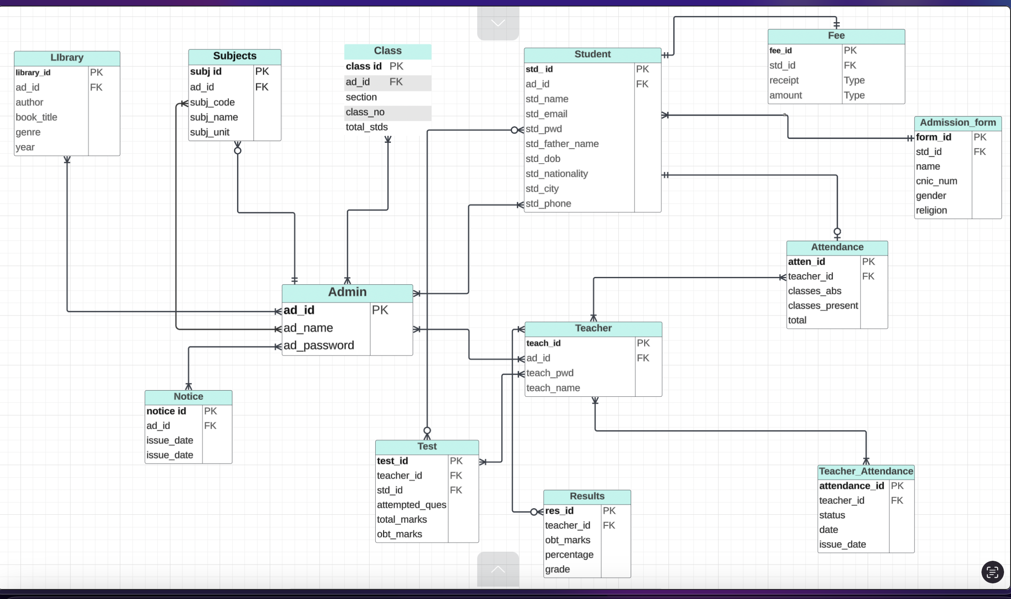

**SQL CODE:**

* **ADMIN**

Create table Admin (

ad_id number not null constraint admin_pk primary key,

ad_password varchar2(20) not null,

ad_name varchar2(45) not null

)

* **SUBJECTS**

create table Subjects (

subj_id number not null,

subj_name varchar2(30) not null,

subj_unit varchar2(8) not null,

subj_code varchar2(8) not null,

ad_id number not null,

primary key (subj_id),

foreign key(ad_id)references Admin(ad_id)

)

* **STUDENTS**

create table Students (

std_id number not null,

std_name varchar2(50) not null,

std_dob varchar2(25) not null,

std_pwd varchar2(50) not null,

std_fathername varchar2(30) not null,

std_nationality varchar2(30) not null,

std_city varchar2(30) not null,

std_phoneno varchar2(15) not null,

std_email varchar2(30) not null,

ad_id not null,

primary key(std_id),

foreign key(ad_id) references ADMIN(ad_id)

)

* **CLASS**

create table Class (

class_id number not null,

class_roomno varchar2(4) not null,

class_section varchar2(3) not null,

class_totalstd number not null,

ad_id number not null,

primary key(class_id),

foreign key(ad_id) references Admin(ad_id)

)

* **TEACHERS**

CREATE table Teachers

(

teacher_id Number not null,

teacher_name varchar(30) not null,

teacher_phoneno varchar(20)not null,

teacher_pwd varchar(40) not null,

ad_id number not null,

primary key (teacher_id),

foreign key(ad_id) references Admin(ad_id)

)

* **RESULTS**

CREATE TABLE Results

(

total_marks NUMBER NOT NULL,

obt_marks NUMBER NOT NULL,

percentage NUMBER NOT NULL,

grade VARCHAR2(3) NOT NULL,

result_id NUMBER NOT NULL,

teacher_id NUMBER NOT NULL,

PRIMARY KEY (result_id),

FOREIGN KEY (teacher_id) REFERENCES Teachers(teacher_id)

)

* **TEST**

create table test(

TEST_NO number not null,

attempted_ques VARCHAR2(3) NOT NULL,

total_ques VARCHAR(5) NOT NULL,

total_marks NUMBER NOT NULL,

obt_marks NUMBER NOT NULL,

std_id NUMBER NOT NULL,

teacher_id NUMBER NOT NULL,

PRIMARY KEY (TEST_NO),

FOREIGN KEY (std_id) REFERENCES Students(std_id),

FOREIGN KEY (teacher_id) REFERENCES Teachers(teacher_id)

)

* **FEE**

CREATE TABLE Fee

(

fee_id NUMBER NOT NULL,

fee_receipt VARCHAR2(15) NOT NULL,

fee_amount NUMBER NOT NULL,

std_id NUMBER NOT NULL,

PRIMARY KEY (fee_id),

FOREIGN KEY (std_id) REFERENCES Students(std_id)

)

* **NOTICE**

CREATE TABLE Notice

(

issue_date date NOT NULL,

notice_id NUMBER NOT NULL,

notice_subj VARCHAR2(100) NOT NULL,

ad_id NUMBER NOT NULL,

PRIMARY KEY (notice_id),

FOREIGN KEY (ad_id) REFERENCES Admin(ad_id)

)

* **ADMISSION_FORM**

CREATE TABLE Admission_Form

(

form_id NUMBER NOT NULL,

name VARCHAR(40) NOT NULL,

cnic_num VARCHAR2(15) NOT NULL,

religion VARCHAR2(20) NOT NULL,

gender VARCHAR2(12) NOT NULL,

std_id NUMBER NOT NULL,

PRIMARY KEY (form_id),

FOREIGN KEY (std_id) REFERENCES Students(std_id)

)

* **ATTENDANCE**

CREATE TABLE Attendance

(

classes_present NUMBER NOT NULL,

classes_abs NUMBER NOT NULL,

classes_total NUMBER NOT NULL,

attendance_id NUMBER NOT NULL,

teacher_id NUMBER NOT NULL,

PRIMARY KEY (attendance_id),

FOREIGN KEY (teacher_id) REFERENCES Teachers(teacher_id)

)

* **TEACHER_ATTENDANCE**

CREATE TABLE Teacher_attendance (

teachattendance_id NUMBER NOT NULL,

teachattendance_date DATE NOT NULL,

teachattendance_status VARCHAR2(15) NOT NULL,

teacher_id number not null,

PRIMARY KEY (teachattendance_id),

FOREIGN KEY (teacher_id) REFERENCES teachers(teacher_id)

)

* **LIBRARY**

CREATE TABLE library (

book_id number Not null,

title VARCHAR(255) NOT NULL,

author VARCHAR(255) NOT NULL,

published_year date NOT NULL,

genre VARCHAR(100),

ad_id number NOT NULL,

primary key(book_id),

foreign key(ad_id)REFERENCES Admin(ad_id)

)

**SCHEMA OF ORGANIZATION:**

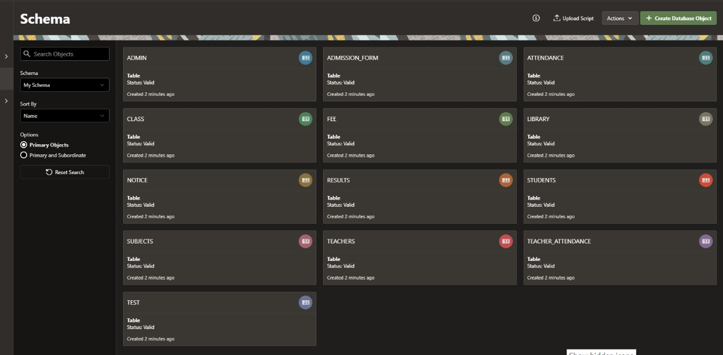

**USER PRIVELEGES:**

* Admin: Full access to all tables and operations as well as manage the results, view attendance, and issue notice.
* Students: Access to browse attendance, view results, and verify fees update.

**QUERIES:**

* **SELECT QUERIES**  
  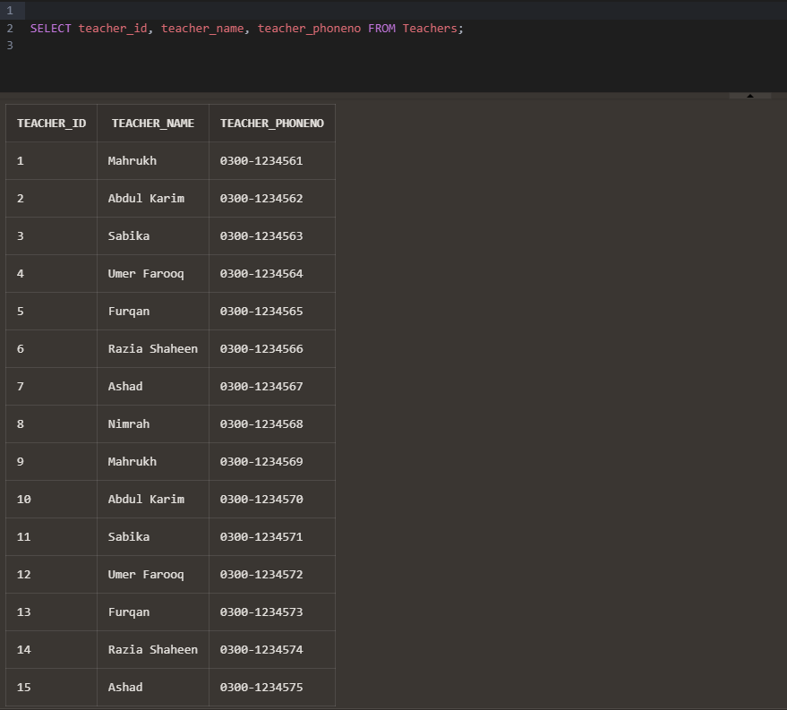  
  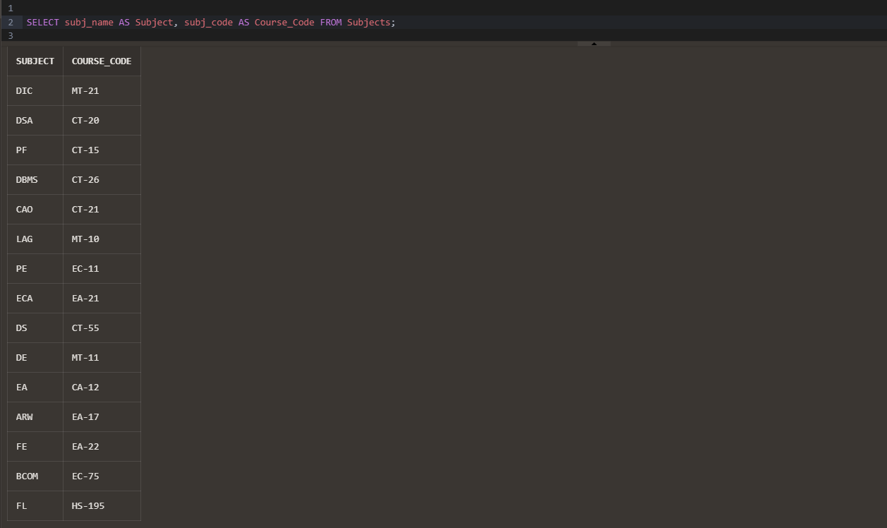
* **WHERE QUERIES**  
  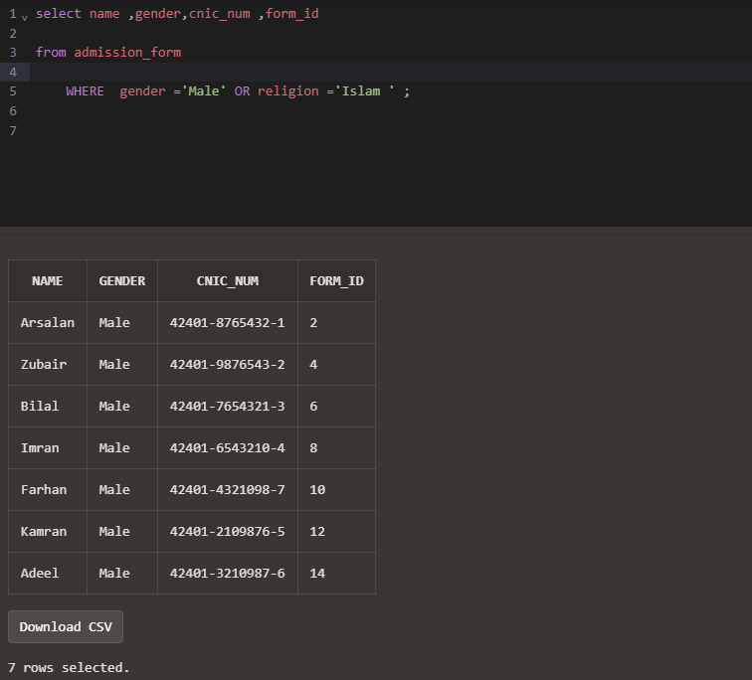
* **SUBQUERY**

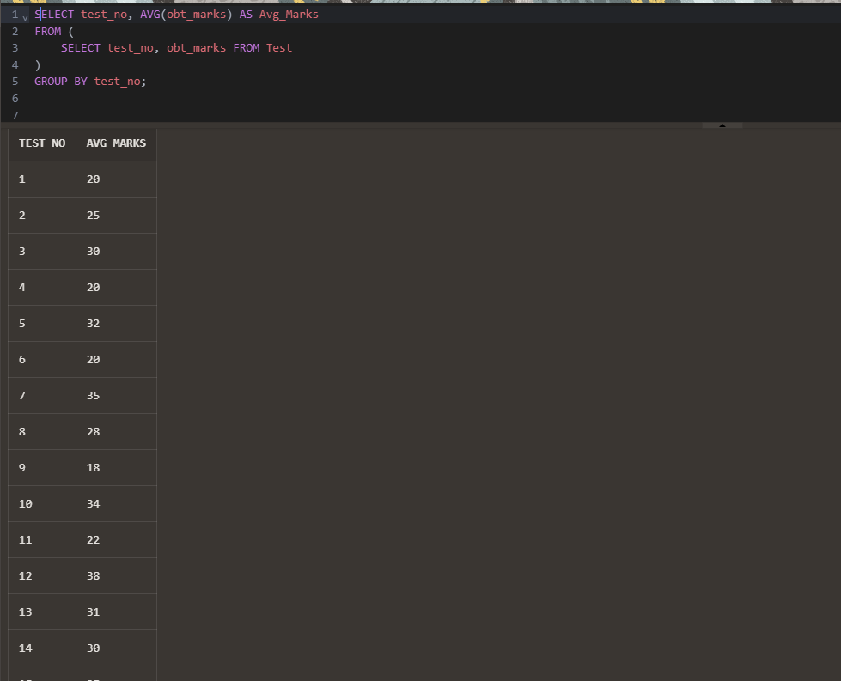

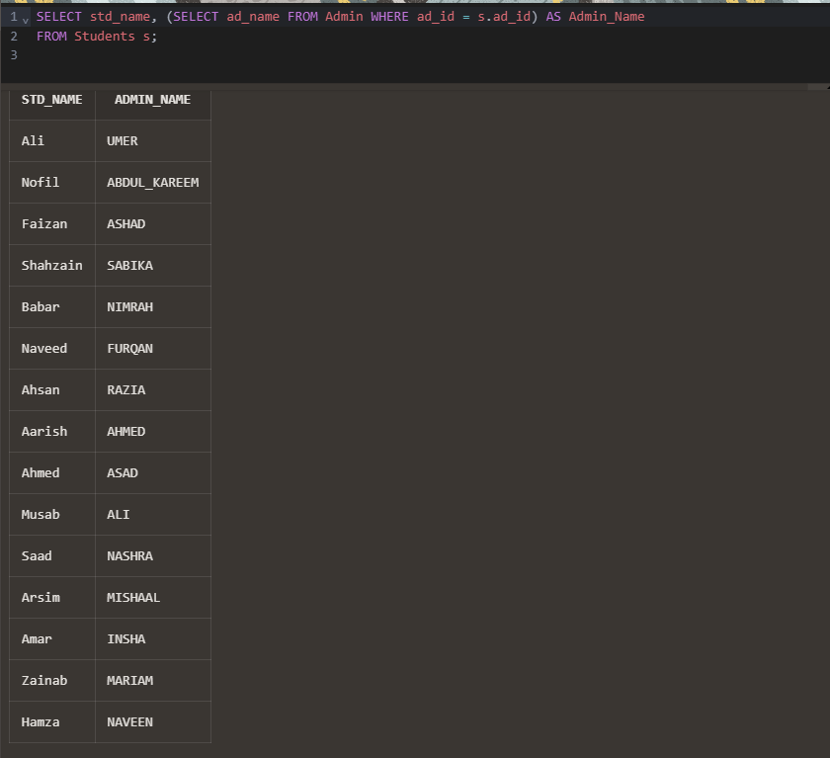

* **JOIN**

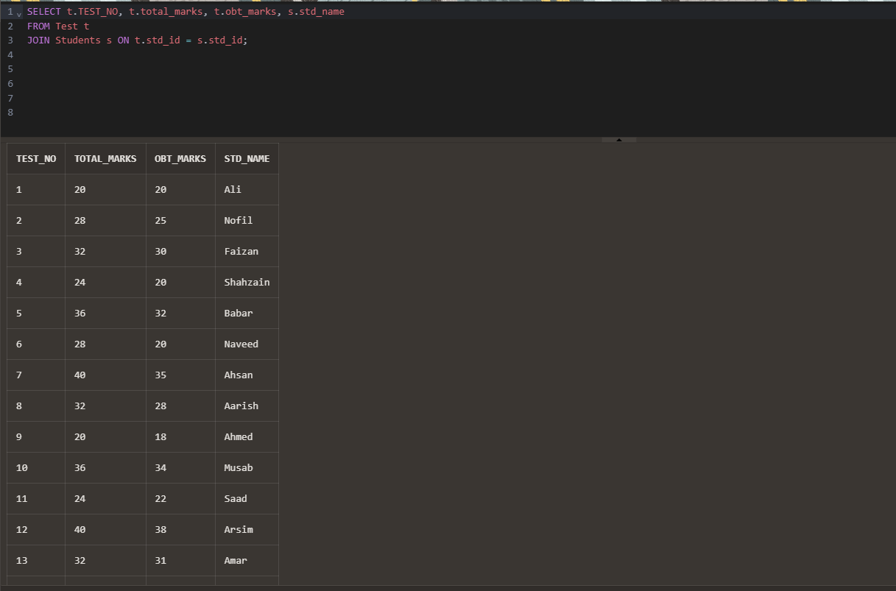

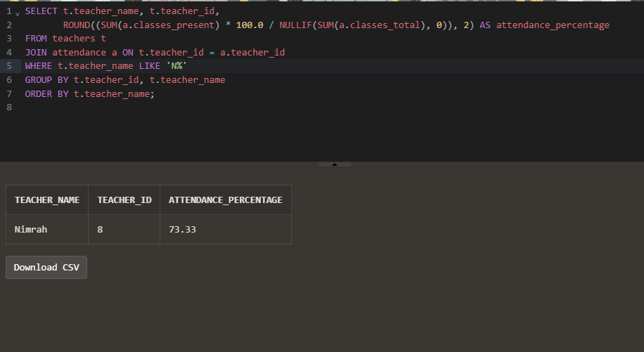

* **SINGLE-ROW**

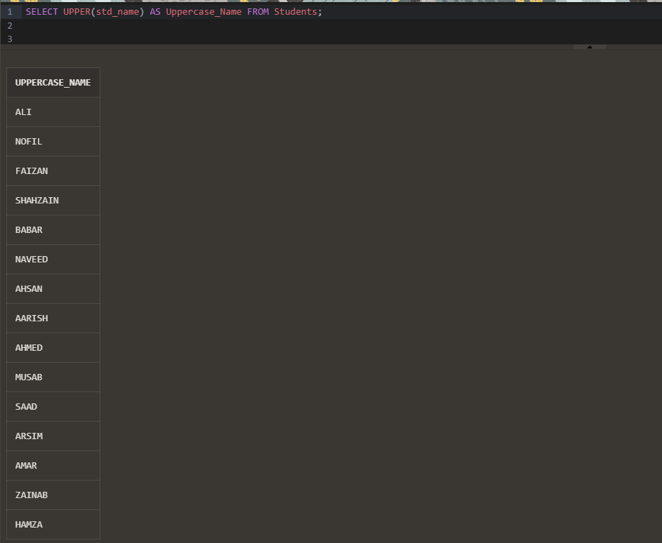

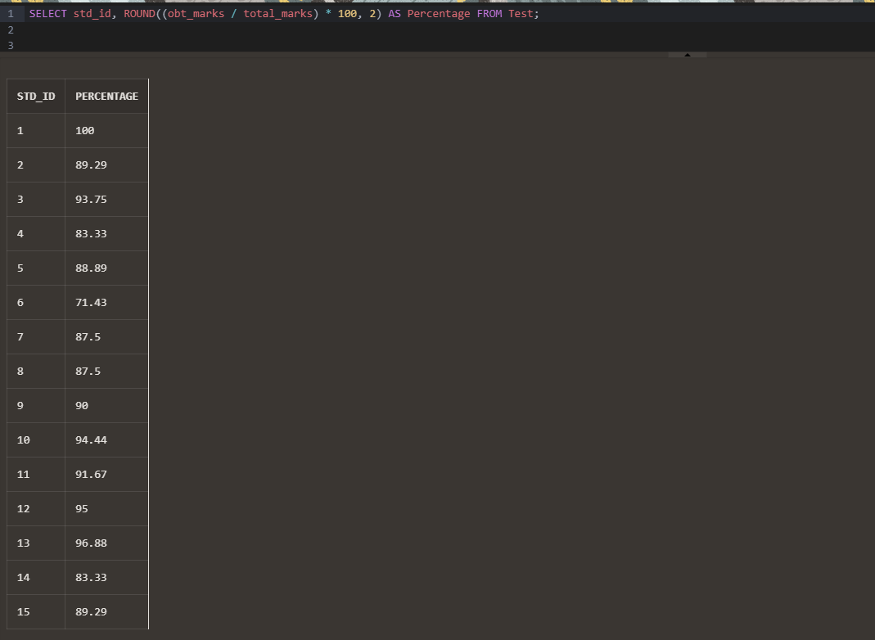

* **FUNCTIONS**

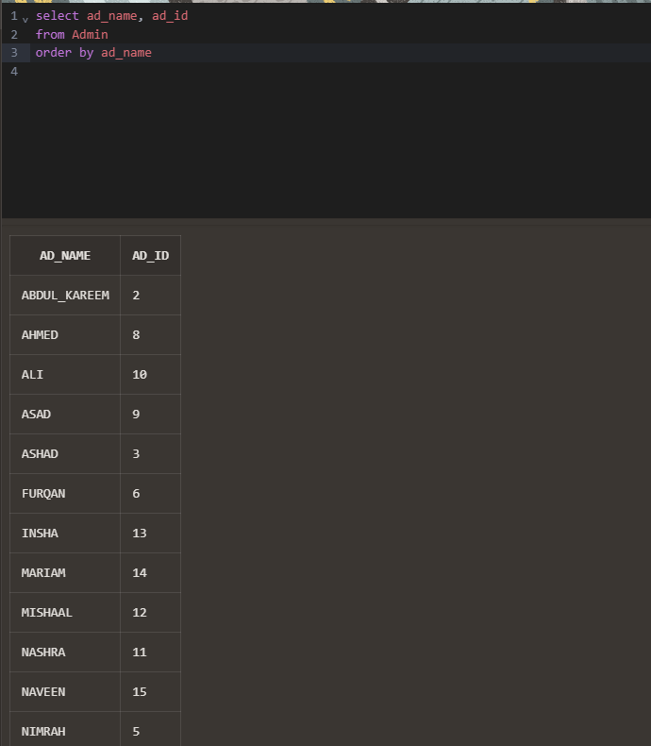

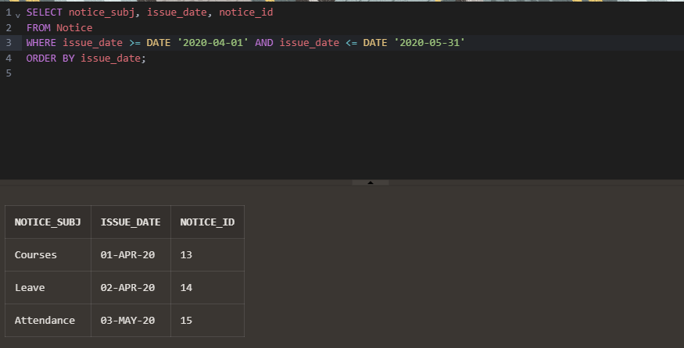

**CONCLUSION:**

Our organization is committed to excellence in education and administration. By implementing a robust database system, we have streamlined various processes, ensuring efficient management of academic records, user privileges, and institutional data. The creation of distinct user roles—Admin, Teacher, and Student—reflects our dedication to providing tailored access and responsibilities, enhancing security and operational efficiency. This structured approach fosters a collaborative environment where administrators can oversee operations seamlessly, teachers can focus on delivering quality education, and students can easily access their academic information.

Through these efforts, we aim to create a supportive and dynamic educational ecosystem that empowers all stakeholders, promotes transparency, and upholds the highest standards of educational excellence.